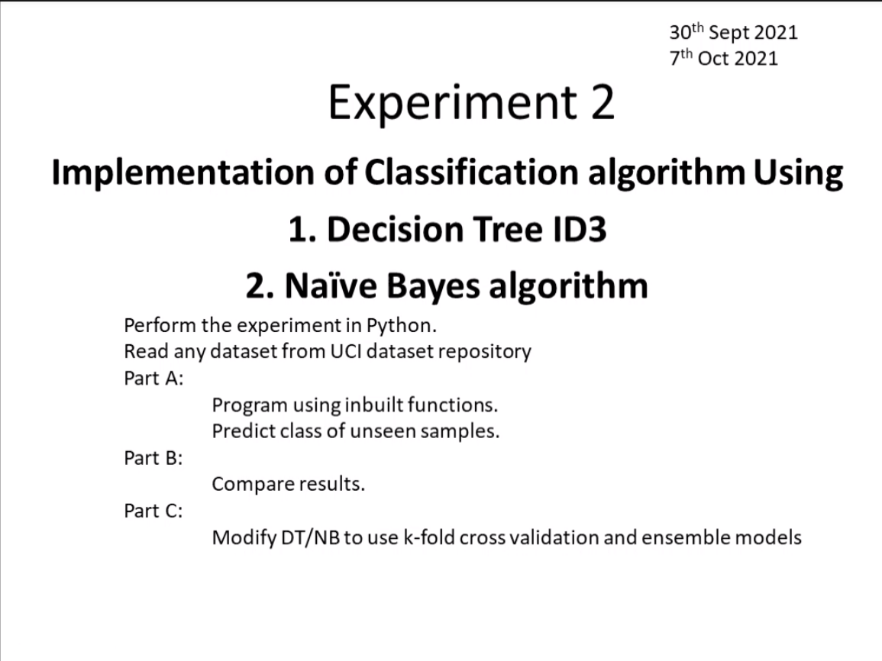

Write about classification theory

Put ss

Dont insert ipynb

Read CSV

Split dataset into train and test

What libraries would you be using

Compare results

Plot comparison

Learn Plotting in py